## HC-SR04 Ultrasonic Sensor

The HC-SR04 is a type of ultrasonic sensor which uses sonar to find out the distance of the object from the sensor. It provides an outstanding range of non-contact detection with high accuracy & stable readings. It includes two modules like ultrasonic transmitter & receiver. This sensor is used in a variety of applications like measurement of direction and speed, burglar alarms, medical, sonar, humidifiers, wireless charging, non-destructive testing, and ultrasonography.

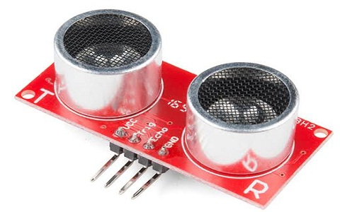

### HC-SR04 Ultrasonic Sensor Pin Configuration

This sensor includes four pins and the pin configuration of this sensor is discussed below.

* Pin1 (Vcc): This pin provides a +5V power supply to the sensor.
* Pin2 (Trigger): This is an input pin, used to initialize measurement by transmitting ultrasonic waves by keeping this pin high for 10us.
* Pin3 (Echo): This is an output pin, which goes high for a specific time period and it will be equivalent to the duration of the time for the wave to return back to the sensor.
* Pin4 (Ground): This is a GND pin used to connect to the GND of the system.

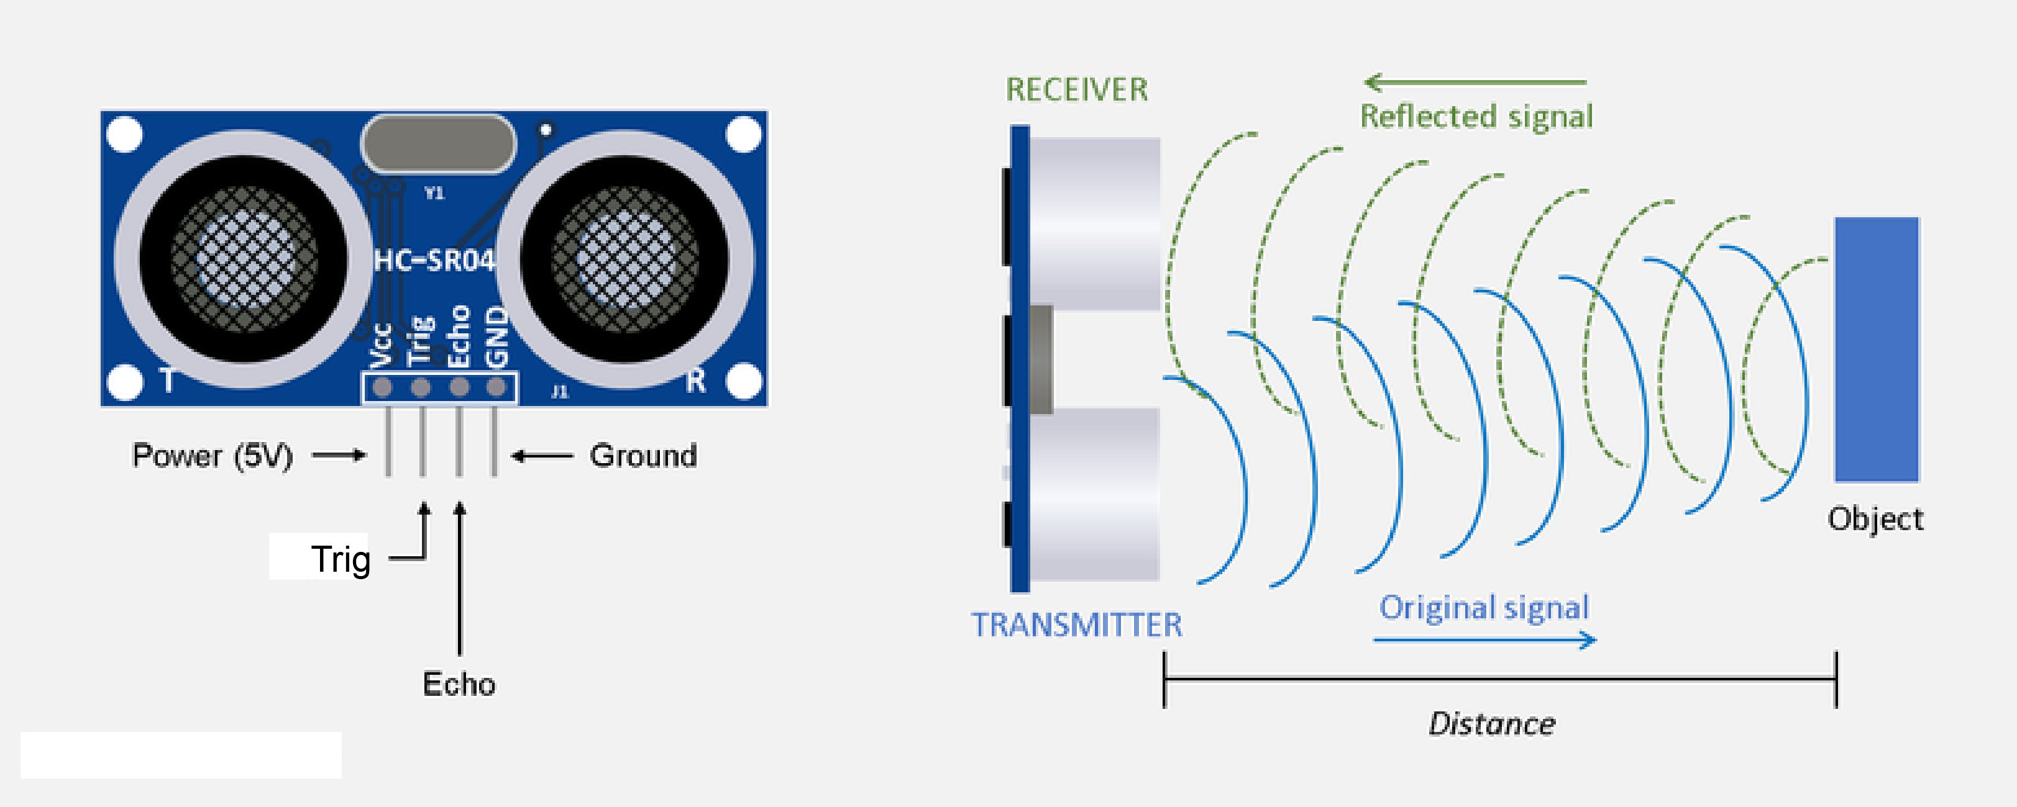

### Features

The **features of the HC-SR04 sensor** include the following

* The [power supply](https://www.elprocus.com/classification-power-supply-different-types/) used for this sensor is +5V DC
* Dimension is 45mm x 20mm x 15mm
* Quiescent current used for this sensor is <2mA
* The input pulse width of trigger is10uS
* Operating current is 15mA
* Measuring angle is 30 degrees
* The distance range is 2cm to 800 cm
* Resolution is 0.3 cm
* Effectual Angle is <15°
* Operating frequency range is 40Hz
* Accuracy is 3mm

### HC-SR04 Ultrasonic Sensor Working

The HC-SR04 Ultrasonic sensor comes with four pins namely Vcc pin, Trigger pin, Echo pin, & Ground pin. This sensor is used to measure the accurate distance between the target and the sensor. This sensor mostly works on the sound waves.

When the power supply is given to this module, it generates the sound waves to travel throughout the air to hit the necessary object. These waves strike and come back from the object, then collects by the receiver module.

Here both the distance as well as time has taken is directly proportional because the time taken for more distance is high. If the trigger pin is kept high for 10 µs, then the ultrasonic waves will be generated which will travel at the sound speed. So it creates eight cycles of sonic burst that will be gathered within the Echo pin. This ultrasonic sensor is interfaced with Arduino to gauge the necessary distance between sensor & object. The distance can be calculated using the following formula.

**S = (V x t)/2**

Where the ‘S’ is the required distance

‘V’ is the sound’s speed

‘t’ is the time taken for sound waves to return back after striking the object.

The actual distance can be calculated by dividing its value with 2 as the time will be twice once the waves travel and get back from the sensor.

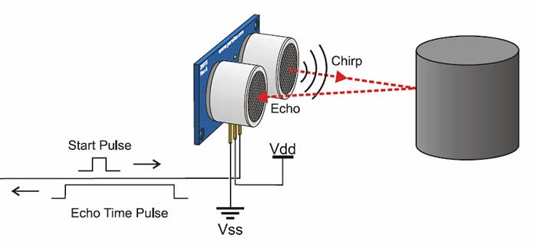

The ultrasonic sensor (or transducer) works on the same principles as a radar system. An ultrasonic sensor can convert electrical energy into acoustic waves and vice versa. The acoustic wave signal is an ultrasonic wave traveling at a frequency above 18kHz. The famous HC SR04 ultrasonic sensor generates ultrasonic waves at 40kHz frequency.

Typically, a microcontroller is used for communication with an ultrasonic sensor. To begin measuring the distance, the microcontroller sends a trigger signal to the ultrasonic sensor. The duty cycle of this trigger signal is 10µS for the HC-SR04 ultrasonic sensor. When triggered, the ultrasonic sensor generates eight acoustic (ultrasonic) wave bursts and initiates a time counter. As soon as the reflected (echo) signal is received, the timer stops. The output of the ultrasonic sensor is a high pulse with the same duration as the time difference between transmitted ultrasonic bursts and the received echo signal.

[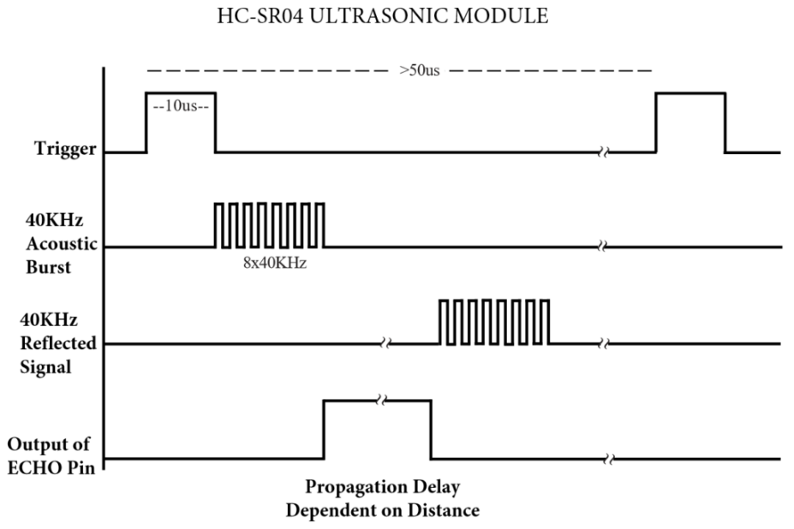](https://rh6stzxdcl1wf9gj1fkj14uc-wpengine.netdna-ssl.com/wp-content/uploads/2019/08/Figure-2.png)

Figure 2: Representation of trigger signal, acoustic bursts, reflected signal and output of echo pin. (Source: HC-SR04 User Guide)

The microcontroller interprets the time signal into distance using the following functions:

[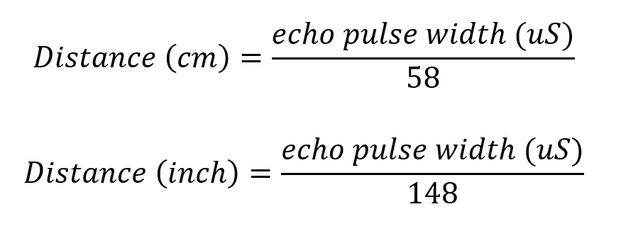](https://rh6stzxdcl1wf9gj1fkj14uc-wpengine.netdna-ssl.com/wp-content/uploads/2019/08/Equation-set-1.png)

Theoretically, the distance can be calculated using the TRD (time/rate/distance) measurement formula. Since the calculated distance is the distance traveled from the ultrasonic transducer to the object—and back to the transducer—it is a two-way trip. By dividing this distance by 2, you can determine the actual distance from the transducer to the object. Ultrasonic waves travel at the speed of sound (343 m/s at 20°C). The distance between the object and the sensor is half of the distance traveled by the sound wave.[iv] The following equation calculates the distance to an object placed in front of an ultrasonic sensor:

[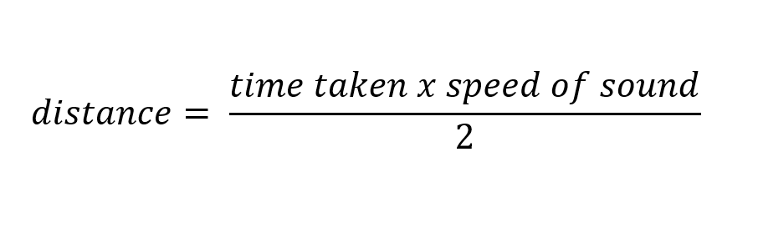](https://rh6stzxdcl1wf9gj1fkj14uc-wpengine.netdna-ssl.com/wp-content/uploads/2019/08/equation-set-2.png)

­­­­